**Submission Link:** <https://forms.gle/TFAJ4BfkCPu2R6fT9>

**Submission Guidelines:**

1. You can code all of them either in Python or Java. But you should choose 1 language for all tasks.
2. For each task write separate python files like task1.py, task2.py and so on.
3. For each task include the input files(if any) in the submission folder.
4. All files (input and code) **MUST** be put in a folder. The folder **MUST** be named following the format **sec_ID_labNo**. Zip this folder. This will result in a zip format of **sec_ID_labNo.zip**. (Example: 2_20101234_6.zip). Submit this zip in the above mentioned submission link.
5. You **MUST** follow all the guidelines, naming/file/zipping convention stated above.

Failure to follow instructions will result in straight 50% mark deduction.

**Problem Description:**

The following tasks needed to be solved by using dynamic Programming. Dynamic programming is a way of finding the optimal solution of a problem where it reduces the call of functions by storing their results in every sequence. It compares the results of every step and from the comparison finds out the optimal solution. Longest common subsequence (LCS) is such an algorithm that functions as a dynamic approach. It basically finds out the longest subsequence which is common to the given sequences.

Read the task descriptions carefully and implement the algorithm using either Java or Python or any language you are comfortable with. The output format **MUST** match exactly as shown in each task.

**Problem 1 (LCS) [10 Marks]:**

PUBGM (Player Unknown’s BattleGrounds Mobile) is one of the most popular online battle royale games. PMPL (PUBGM Pro League) is the biggest tournament of south asia and Future Station a team from Bangladesh has qualified for the final round of the tournament. MagneT also known as “The zone magnet” for his accuracy of in-game zone predictions is the IGL (Team leader) of the team and he predicted the zone sequence before a match in the finals. For the match of map Erangel his prediction was,

| **Zone number** | **Zone center** | **Keyword** |
| --- | --- | --- |
| 1 | Yasnaya | Y |
| 2 | Pochinki | P |
| 3 | School | S |
| 4 | Rozhok | R |
| 5 | Farm | F |
| 6 | Mylta | M |
| 7 | Shelter | H |
| 8 | Prison | I |

On that match the team had a very good result and actual zone sequence of that match was:

| **Zone number** | **Zone center** | **Keyword** |
| --- | --- | --- |
| 1 | Yasnaya | Y |
| 2 | Rozhok | R |
| 3 | School | S |
| 4 | Pochinki | P |
| 5 | Farm | F |
| 6 | Mylta | M |
| 7 | Shelter | H |
| 8 | Prison | I |

Now, you have to find out the longest common zone sequence from MagneT’s prediction and actual match by using LCS (Longest Common Subsequence) algorithm. Then verify the correctness of MagneT’s prediction. For correctness you will use the formula given below.

***Correctness = (Length of longest common zone sequence × 100) ÷ Number of zones***

**Note:** Zone meta given here is completely fictional. Please do not match it with the real game zone meta.

**Hint:** You have to store zone center values according to keywords first. You can use the following pseudo code of LCS algorithm.

**LCS**(X, Y):

m <- length of X + 1

n <- length of Y + 1

**for** i <- 1 to m:

c[i,0] <- 0

t[i,0] <- null/None

**for** j <- 1 to n:

c[0,j] <- 0

t[0,j] <- null/None

**for** i <- 1 to m:

**for** j <-1 to n:

**if** X[i] = Y[j]:

c[i,j] <- c[i-1,j-1]+1

t[i,j] <- diagonal

**else if** c[i-1,j] >= c[i,j-1]:

c[i,j] <- c[i-1,j]

t[i,j] <- up

**else**:

c[i,j] <- c[i,j-1]

t[i,j] <- left

**Sample Input:**

8 //Number of zones

YRSPFMHI //Zone sequence of the match

YPSRFMHI //Zone sequence of MagneT’s prediction

**Sample Output:**

Yasnaya Pochinki Farm Mylta Shelter Prison

Correctness of prediction: 75%

**Problem 2 (LCS) [15 Marks]:**

You know about how to find the Longest Common Subsequence (LCS) between two strings using dynamic programming. Let’s make it a bit challenging. I will give you three strings instead of two, and now you need to find out the Longest Common Subsequence (LCS) among these three strings. Sounds interesting, right? I know you can do it!

**Input:**Each input will consist of three strings in each line. The length of each string will be no greater than 100.

**Output:**

Output the **length of the longest common subsequence** of the given three strings.

**Sample Input 1:**

hell  
hello

bella

**Sample Output 1:**

3

**Sample Input 2:**

abbcdab

daccbadb  
abccdaab

**Sample Output 2:**4

**Hint:** For this problem you have to construct LCS for 3 parameters. You can use the following pseudo code to find out the longest common subsequence of three strings.

**LCS**(X, Y, Z):

m <- length[X] + 1

n <- length[Y] + 1

o <- length[Z] + 1

c[m][n][o]

t[m][n][o]

**for** i <- 1 to m:

**for** j <- 1 to n:

**for** k <-1 to o:

**if** i = 0 **Or** j = 0 **Or** k = 0:

c[i][j][k] <- 0

t[i][j][k] <- null/None

**else:**

**if** x[i] = y[j] And x[i] = z[k]:

c[i][j][k] <- 1 + c[i-1][j-1][k-1]

t[i][j][k] <- diagonal

**else:**

**if** c[i-1][j][k] >= c[i][j-1][k]:

max <- c[i-1][j][k]

**if** max >= c[i][j][k-1]:

c[i][j][k] <- max

t[i][j][k] <- up-up-left

**else:**

max <- c[i][j][k-1]

c[i][j][k] <- max

t[i][j][k] <- left-up-up

**else:**

max <- c[i][j-1][k]

**if** max >= c[i][j][k-1]:

c[i][j][k] <- max

t[i][j][k] <- up-left-up

**else:**

max <- c[i][j][k-1]

c[i][j][k] <- max

t[i][j][k] <- left-up-up

**3D Array:**

We already know how to operate 2D arrays. Now we have to use 3D arrays in order to construct LCS with 3 parameters. Multidimensional array means multiple arrays of different dimensions or sizes can be held by a single array. We will learn about 3D arrays with an example.

Suppose we want to store midterm and final marks separately of four different courses of three students in a single array. We can easily do it by using a 3D array.

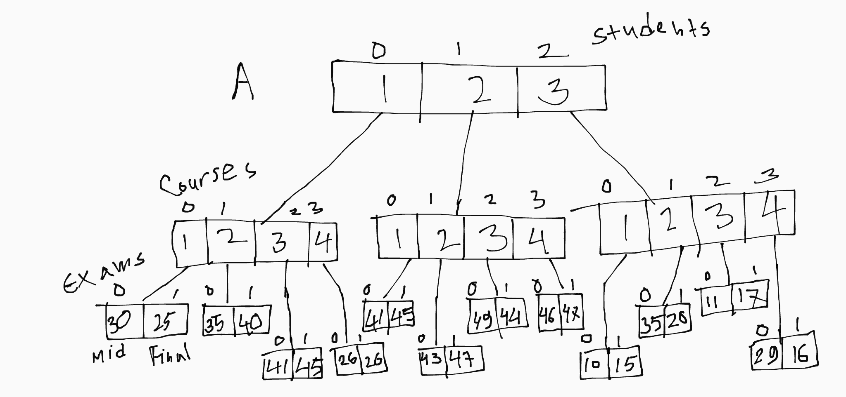

This is the pictorial view of the given scenario.Normally we can denote an array of 3 dimensions by this notation A[ ][ ][ ]. If we initialize this array empirically it will be like,

A[3][4][2]

Here, A is a 3D array where it has a size of 3 which represents 3 students. Each of 3 indices can hold an array of size 4 which indicates the different courses. And indices of these arrays can hold arrays of size 2 where each index represents the marks of mid and final.

For extracting the specific values from array A, we can simply use these instructions,

1. print(A[0][1][0])
2. print (A[2][2][1])
3. print(A[1][3][0])

First command will give 35 as output because first it will access the 0 th index of A. Then it will go through the index number 1 of it’s connected array and finally index number 0 of the array which is connected with the index number 1 of 2nd array will be accessed and give its value as output which is 35. Same procedure will be applied for the rest of the instructions. The second and third commands will give outputs 17 and 46 respectively. For traversing this array you can use the given codes.

**Python:**

**for** i in range(len(A)):

**print**("Student: ",(i+1))

**for** j in range(len(A[i])):

**print**("Course: ",(j+1))

**print**("Marks of Mid and Final: ")

**for** k in range(len(A[i][j])):

**print**(A[i][j][k],end=" ")

**print**()

**print**()

**Java:**

**for** (int i = 0; i < A.length; i++) {

**System.out.println**("Student: "+(i+1));

**for** (int j = 0; j < A[i].length; j++) {

**System.out.println**("Course: "+(j+1));

**System.out.println**("Marks of Mid and Final: ");

**for** (int k = 0; k < A[i][j].length; k++) {

**System.out.print**(A[i][j][k]+" ");

}

**System.out.println**();

}

**System.out.println**();

}

**Output:**

Student: 1

Course: 1

Marks of Mid and Final:

30 25

Course: 2

Marks of Mid and Final:

35 40

Course: 3

Marks of Mid and Final:

41 45

Course: 4

Marks of Mid and Final:

26 26

Student: 2

Course: 1

Marks of Mid and Final:

41 45

Course: 2

Marks of Mid and Final:

43 47

Course: 3

Marks of Mid and Final:

49 44

Course: 4

Marks of Mid and Final:

46 47

Student: 3

Course: 1

Marks of Mid and Final:

10 15

Course: 2

Marks of Mid and Final:

35 20

Course: 3

Marks of Mid and Final:

11 17

Course: 4

Marks of Mid and Final:

29 16